**Assignment_4**

**Name:Gali Sai Jayasri**

**Trainer:Harshee**

**Course:Python &Machine Learning**

**Date:2/06/2022**

**QUESTION_1:**

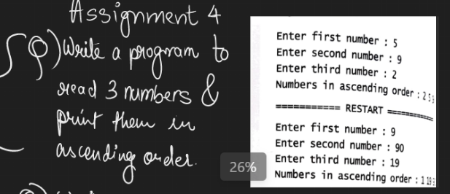

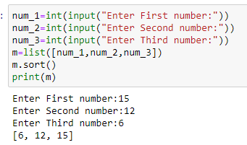

**QUESTION_2:**

